**(39) Agriculture**

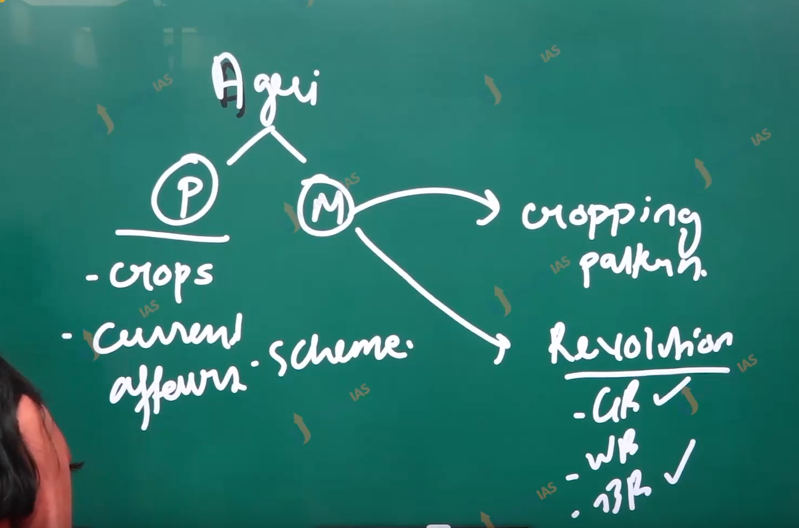

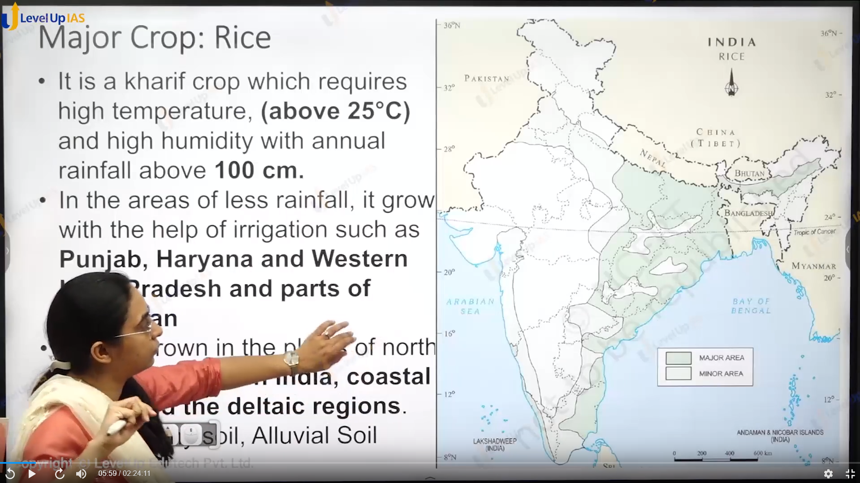

Agriculture:

Major crops:

1. Rice:
   1. It is a kharif crop. It required a high temperature (greater 25 degree Celsius) and high humidity rainfall of 100 cm.
   2. In the area of leases rainfall, it can grow with the help of irrigation. In the area Panjab Haryana western UP.
   3. Rice is majorly grown in the northeast India the northern plane. Coastal region and deltaic region.
   4. Soils: alluvial soil, black cotton coils, loam soil (sand 40 silt 40 and clay 20).

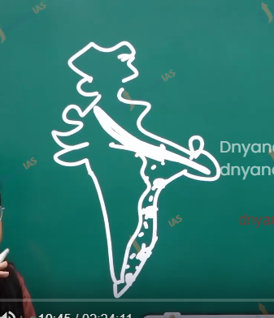

Wheat:

1. Second most important crop. Mainly grown northern and northern western Indian. It required a cool growing season and bright sunshine at a time of ripening.
2. It requires the rainfall of 50 75 cm. which is evenly distributed.
3. Two important zones where wheat is cultivated is Sat lag and Guanga plane and black cotton soil region of deccan. And therefore major wheat producing stage are Panjab Haryana UP MP Bihar rajastan.

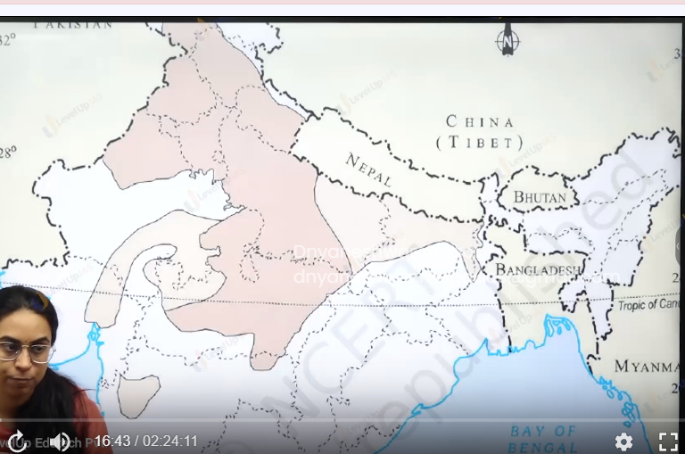

Tea:

1. It is beverages crop and grows on the plantation. It requires the cool climate and well distributed high rainfall 150-200 cm throughout the year.
2. Well distributed rainfall can help in the growth in tender leaves.
3. It can grow well on a gentle slope. Hilly regions it can grow in tropics as well as sub-tropics.
4. The flavor of the tea is imparted due to humidity, dew, flog, etc.

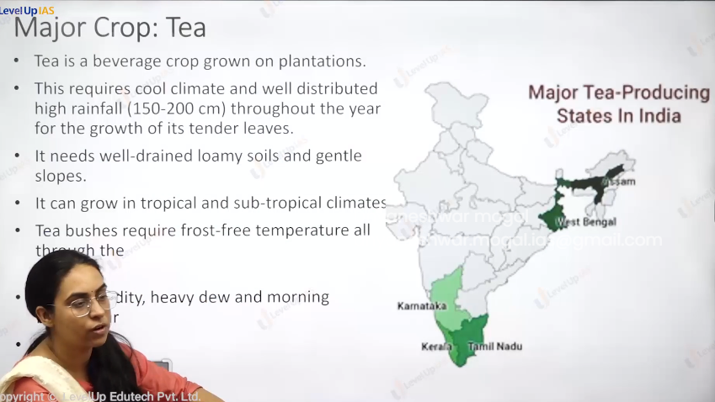

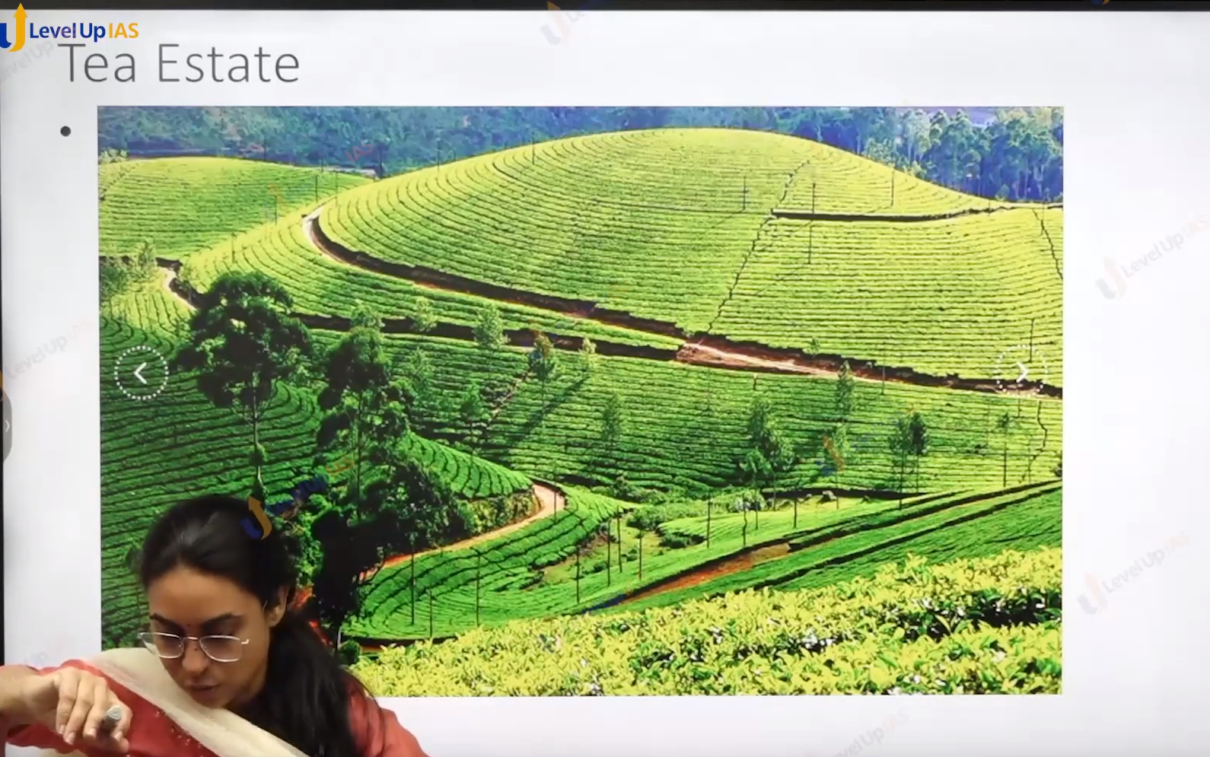

Coffee:

1. Coffee required warm and humid climate with well rain lomi soil.
2. Therefore hill slope are suitable for this crop.
3. Initially this crop is cultivated in baba budan hill kin Karnataka. Even till date 70% is confine to Karnataka.
4. Coffee cultivation is confine to nil Giri hill in Kerala , kar nakta, tamilnadu.

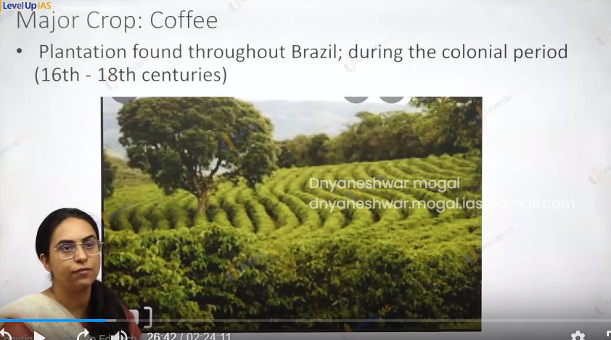

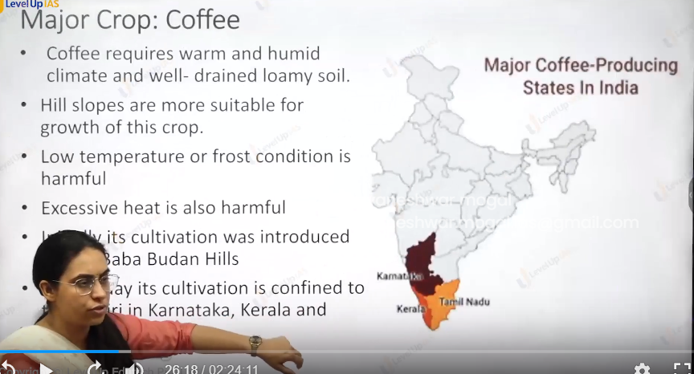

Jute:

1. It is also known as golden fiber. It grows well on alluvial soil it requires high temperature (25) heavy rainfall (125-200 cm) and humid climate.
2. Jute is major cultivated along in west Bengal Andhra Pradesh Odisha and Bihar, Assam.
3. It grows in tropical areas and in well drain fertile are where soil is renew every year.
4. It is a kharif crop.

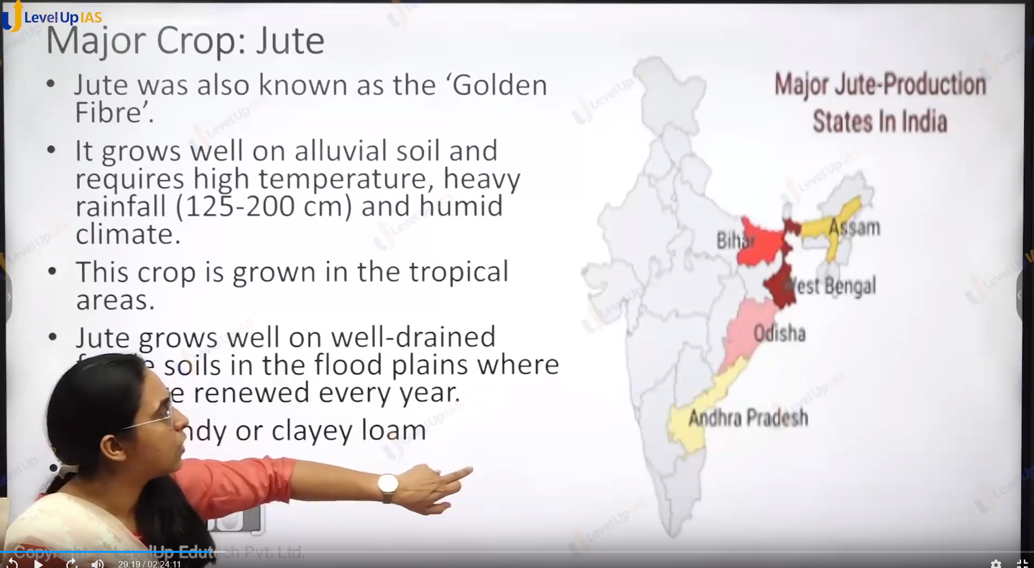

Process of ratting:

1. It refers to the process of extracting jute fiber from the jute stem.
2. Jute stem is kept under free-flowing water so have to facilitate easy removal of jute fiber.
3. It is labor intensive process.

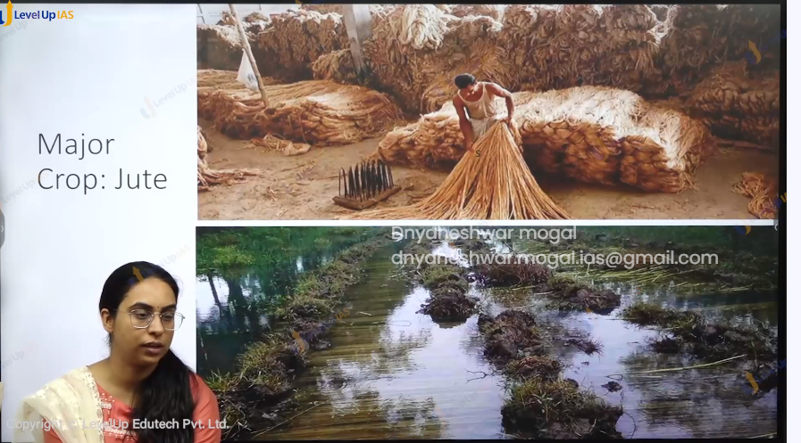

Cotton:

1. Ti requires the high temperature. Light rainfall (50-75) 210 frost free days. Bright sunshine for ripening and busting the crop.
2. It grows best on black cotton soil, and alluvial soil. It is a kharif crop and can be grown in tropical and subtropical area.
3. The moist weather during ball opening and harvesting is harmful as it leads to the spread of disease.
4. Can be grown in tropical and subtropical area Ukraine. is the northern limit of cotton.

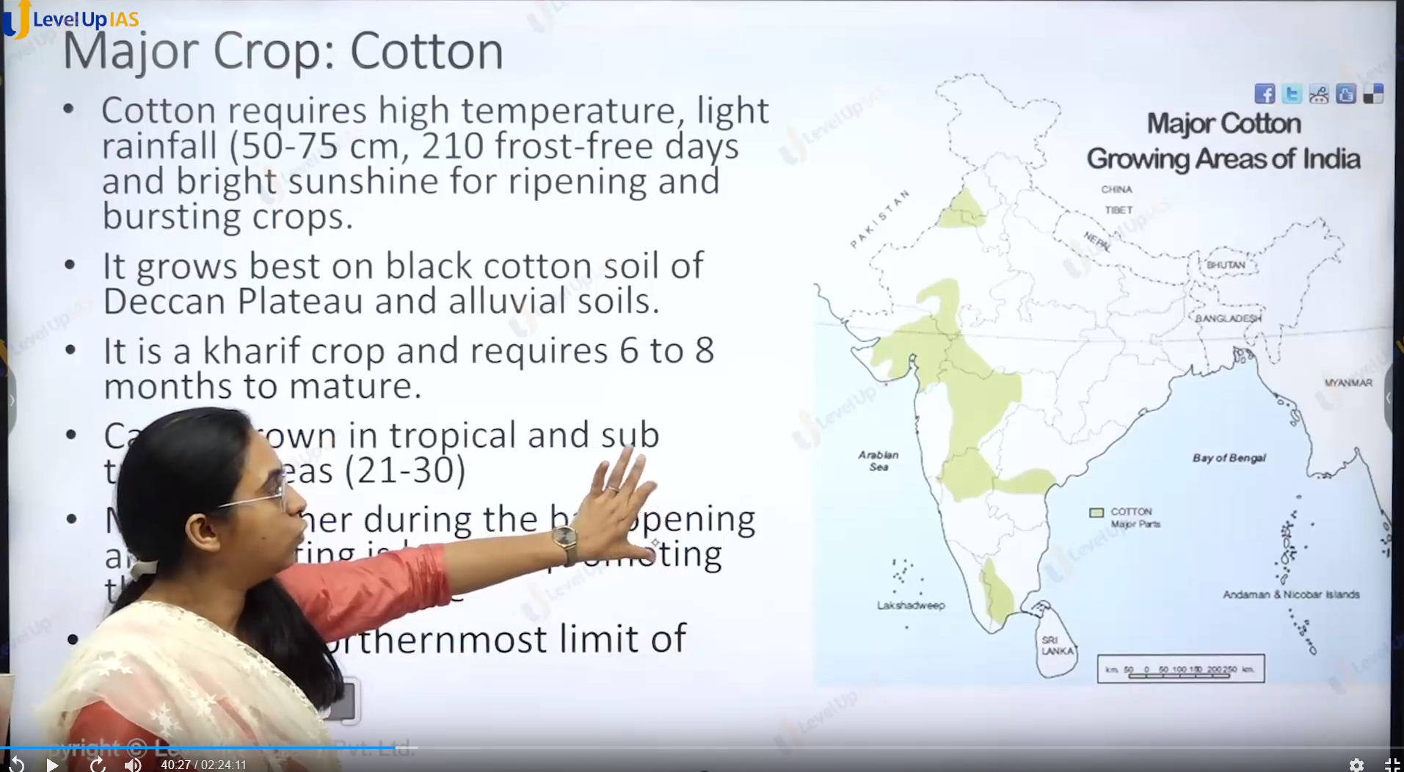

Sugarcane:

1. It is plantation crop it requires the long rainy season of 8 month for it well developed growth.
2. Full grown sugar cane 8 to 12 to 15 months.
3. The conditions need to sugarcane are annually 75 to 100 cm temperature in the range of 21 to 27 degree.
4. It can be grown in the areas of low rainfall. It the help of irrigation support it can be grown in tropical as well as subtropical regions.
5. The soil need Is rich loamy soil. Which is neither too acidic nor alkaline.
6. The traditional belt of sugarcanes is UP, Bihar. Later the crops are cultivated in the regions in Maharashtra (black cotton soil) Cauvery basin), Krishna, Godavari delta, and towards Panjab regions.
7. The greater sucrose yield in topical region.
8. Ratooning : ratooning is pa

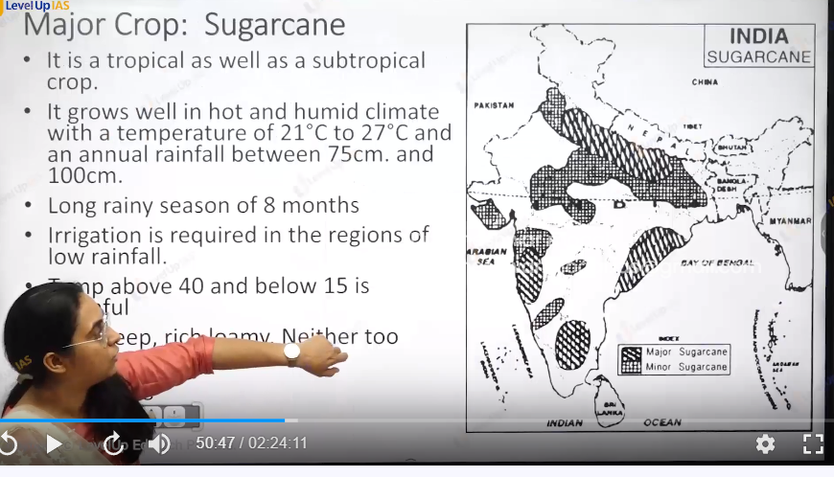

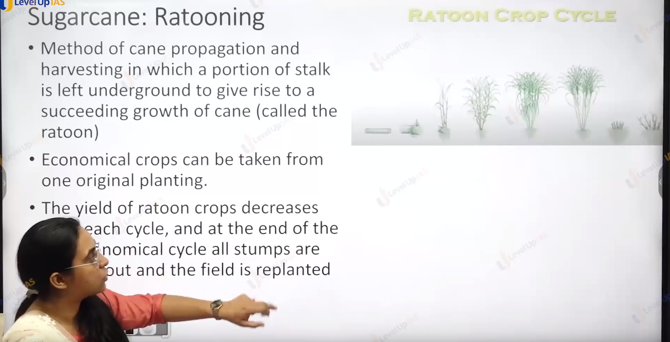

Ratooning:

1. The ratooning is practice of sugarcane proportions and harvesting in which a portion of stem is left which facilitates the faster growth of cane crop, normally sugarcane crop cannot be uprooted as it will take longer time for the growth of sugarcane. Therefore, ratooning is used.
2. The yield in the ratooning crops (seceding sugarcane crops) decreases each cycle. Therefore, at the end of the last economic cycle all stems and crops and ploughed out and the field is replanted.

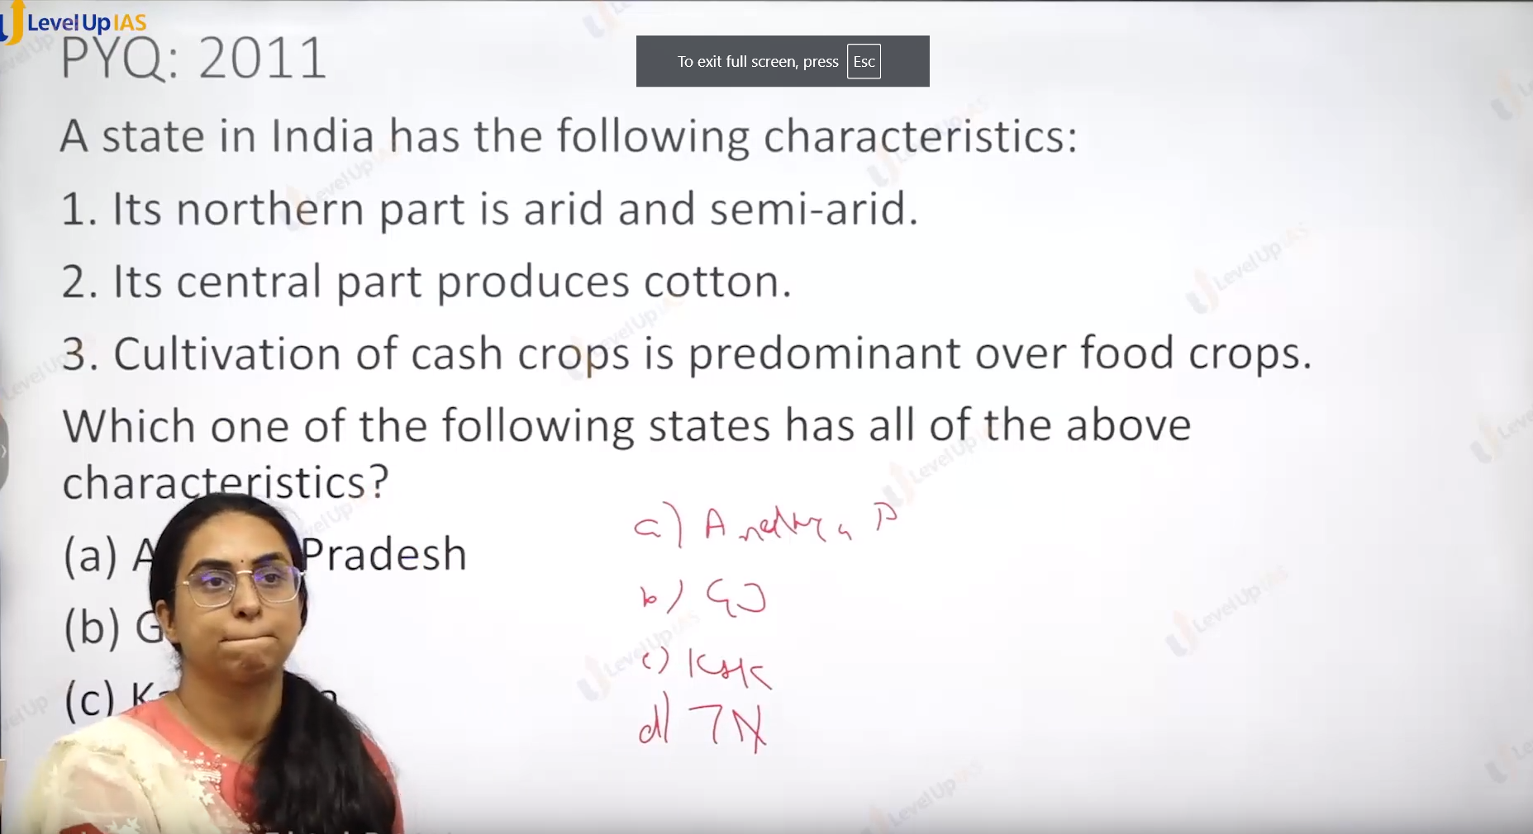

Ans: Gujrat.

AP has not black soil.

Gujarat has black soil.

Tamil Nadu do not produce the cotton.

And Karnataka not central part produce cotton but it upper part may be.

Arid meaning. Very dry and little rain.

No arided in Karnataka.

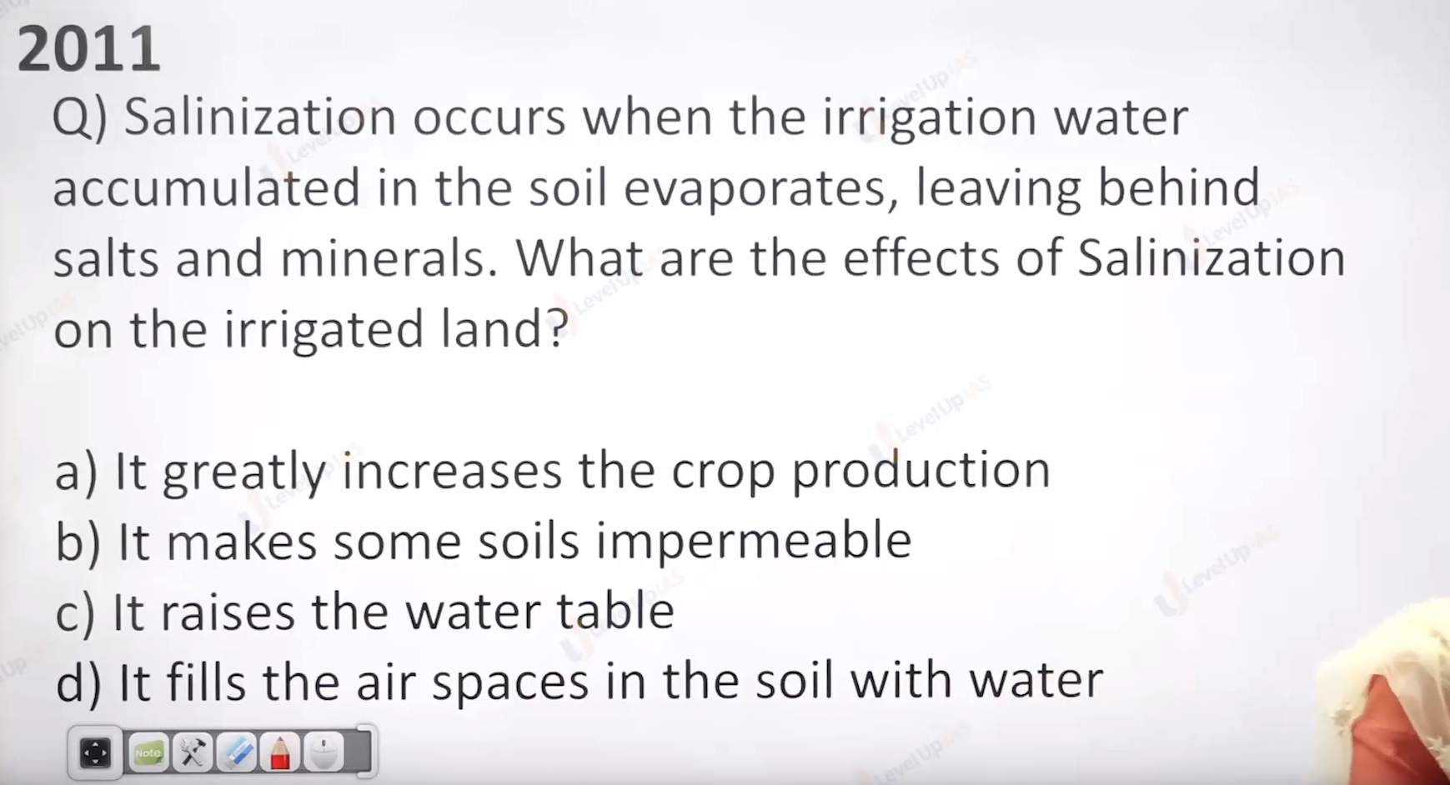

Ans is B

Does not increase production.

Impermeable means not allowing to fluid pass through.

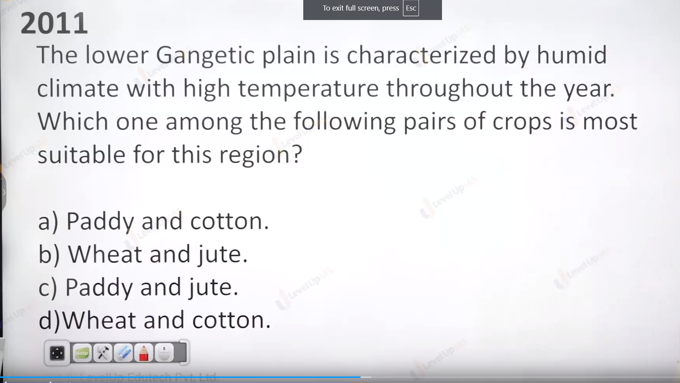\

Ans is C

Meaning up bihar and orisa banga.

Weat and cotton required less water.

So paddy and jute.

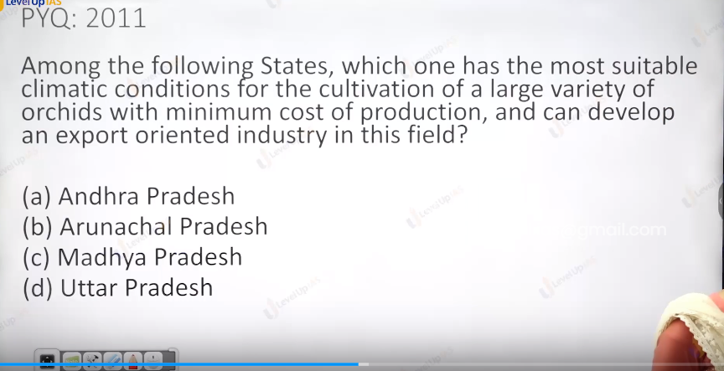

Ans: Arunachal Pradesh.

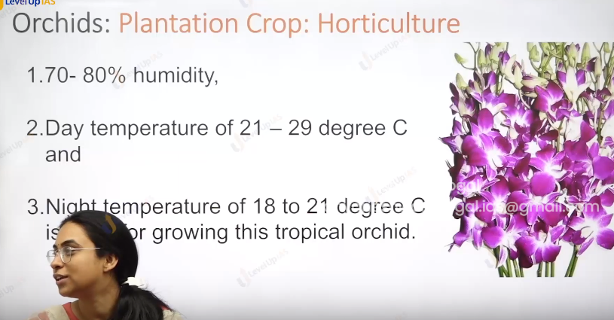

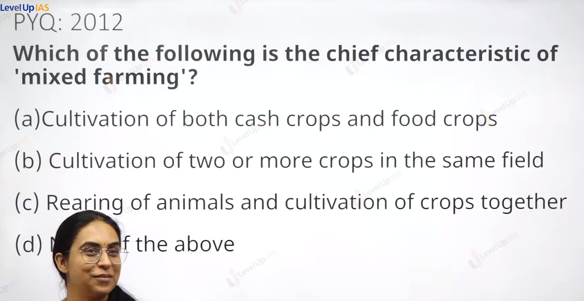

Ans : c

Cultivation of Two and more crops are mixed cropping ..

When you added the animals in to it it mixed farming.

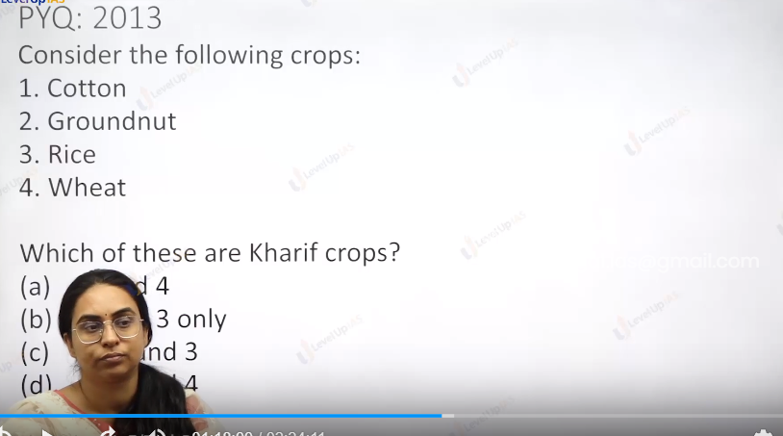

Karif crops : rice required more water so in monsoon season.

And cotton. You are one of cotton producingz farmer. You must know.

Karif : cotton and rice.

Ground nut.

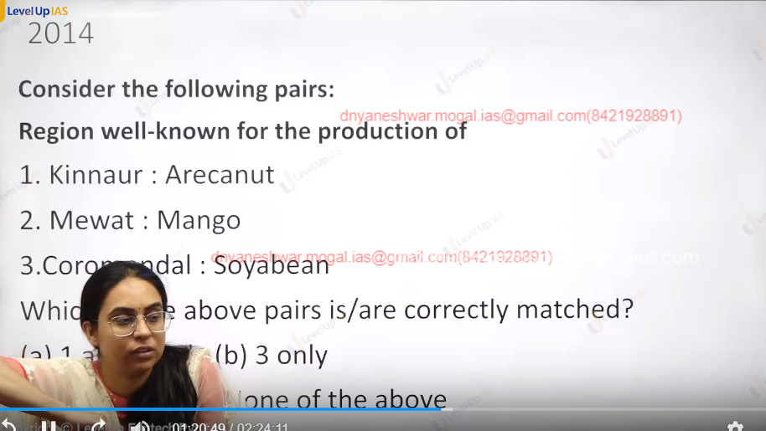

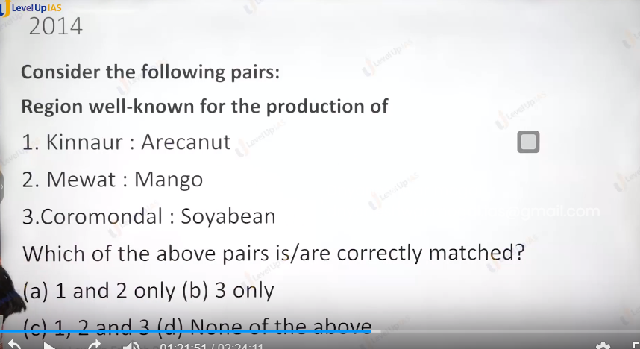

Ans is : d None of above.

Mewat is in haryan, crime activity. Anti social element.

Areca nut : supari,

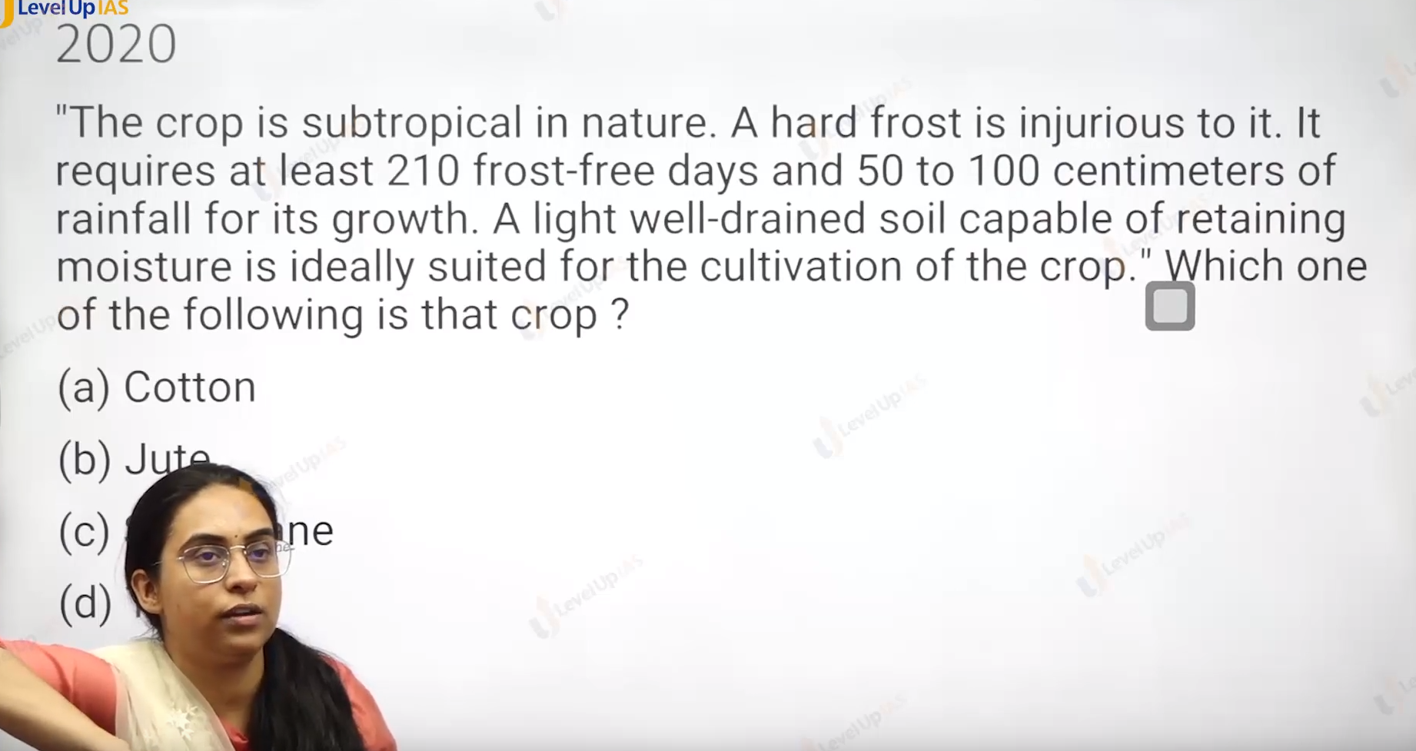

Ans is : cotton A.

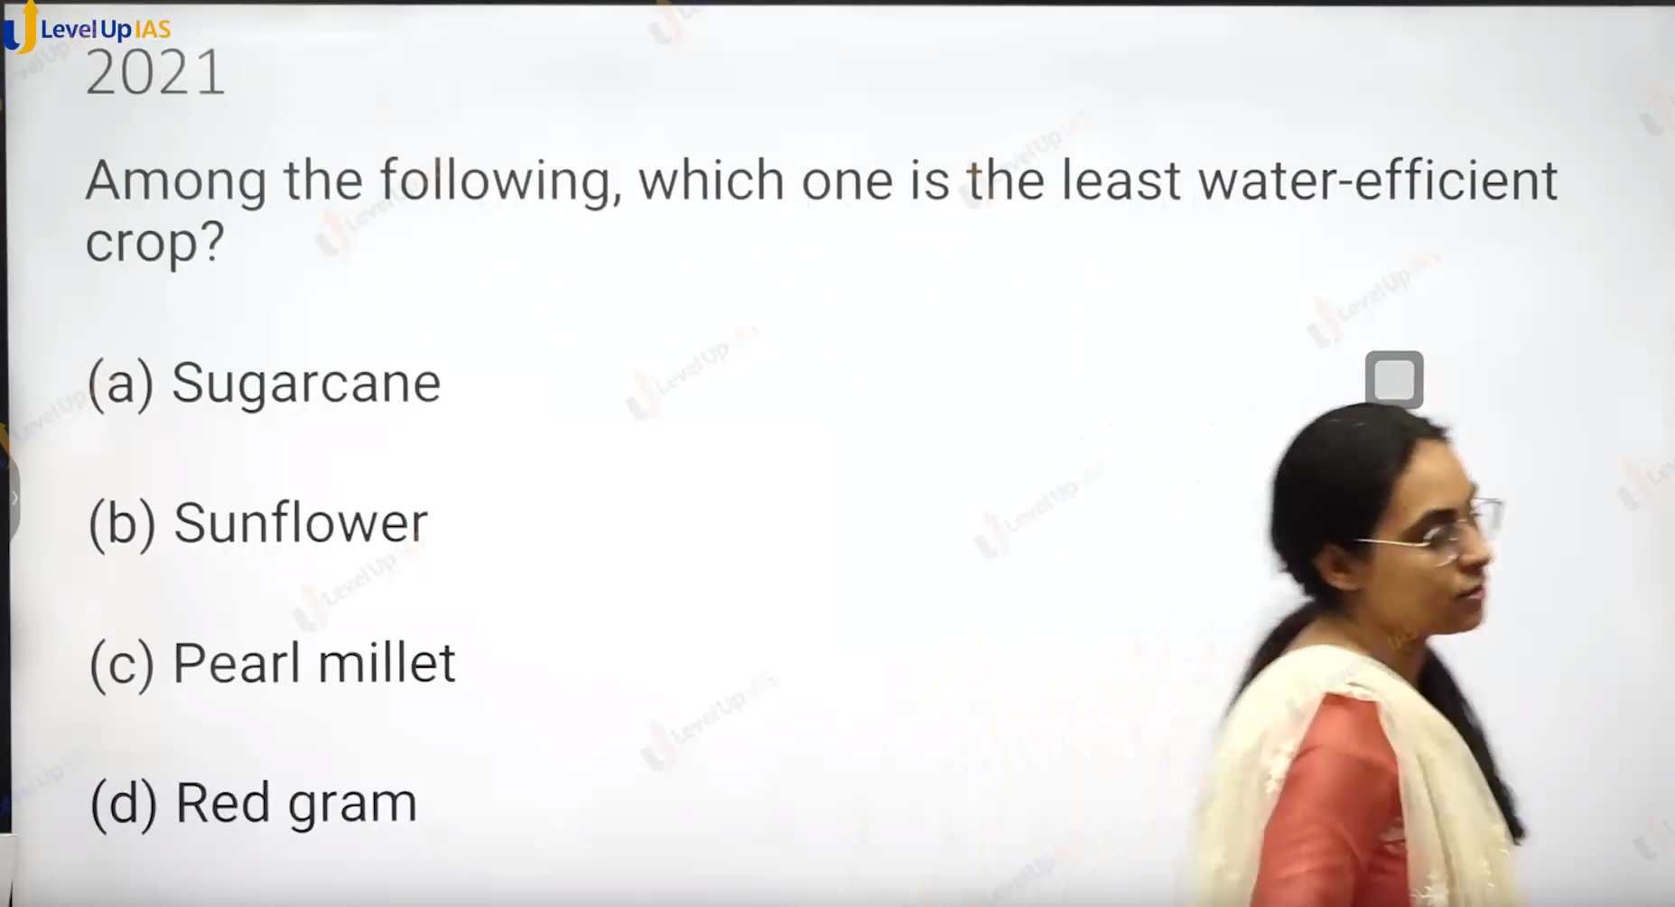

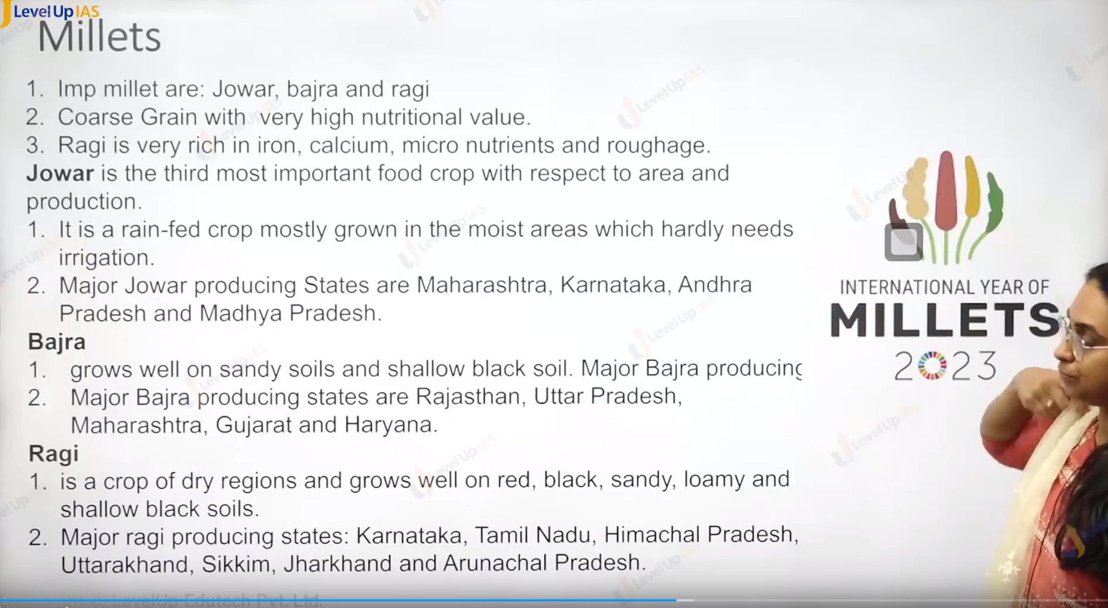

Millets:

1. It is grown in dry regions. The important millets are jowar bajra ragi.
2. They are called coarse grain with very high nutritional value.
3. They are low glycemic index meaning sugar in the blood. Diabetes
4. They are recommended to diabetic people.
5. Jawar is the 3 most important food crop with respect of area and production.
6. It is a rain fed crop and grows in the moist area. which hardly need irrigation.
7. The area where the jawar is grown are MP, MAHARASHTRA, KARNATAKA, Andra Pradesh.
8. Bajra: bajra grows well on the sandi soil and sallow black soil.
9. Major bajra producing states are Rajasthan and UP, Maharashtra. Gujarat, Telangana.

Ragi:

1. It grows on black soil sandy soil. Loamy soil, red soil.
2. Ragi is majorly grown in Karnataka and tamandu and the hilly state of Uttarakhand Sikkim Jharkhand, Arunachal Pradesh, Himachal Pradesh.

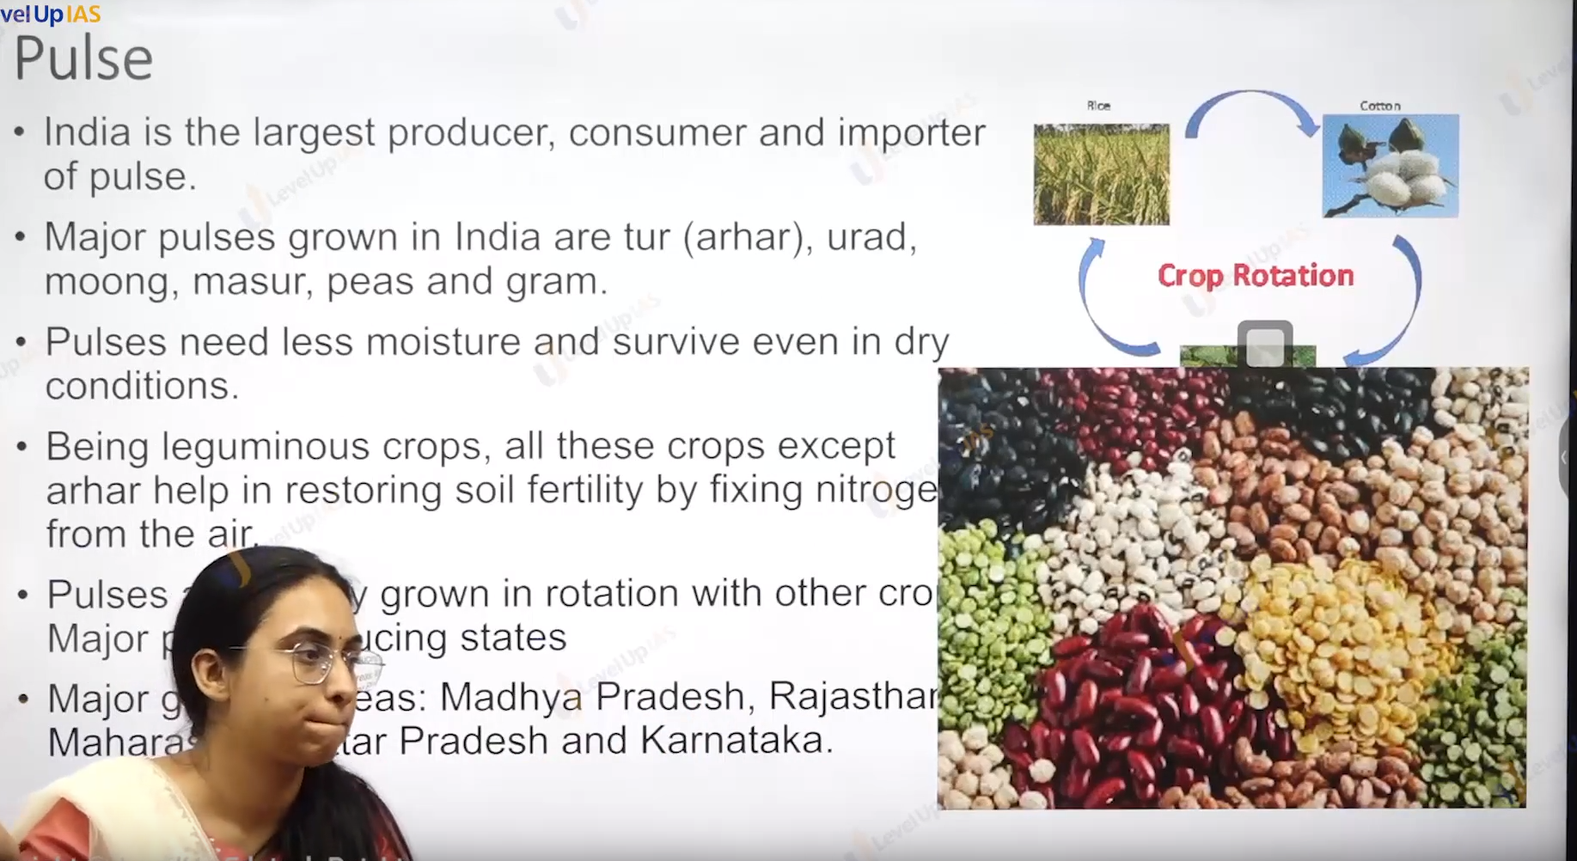

Pulses:

1. India is largest producer consumer and importer of pulses.
2. The pulses grown in India are pigeon pea, Tur ( ahar, urad, moong , masur, peas ,gram.
3. Pulses can be grown in dry condition. Pulse is in form of crop rotation as they help in restoring soil fertility by fixing the nitrogen from the air, areas where pulse production dominate MP, Rajasthan, Maharashtra, UP, Karnataka.
4. Black gram can grow as kharif and rabi crop.
5. Gram is predominant plus accounting for 40% of total pulse production followed by tur 20% fallowed for urad 8% moong 8 %
6. Pulsed account for 20% area for crop production in India.
7. Rabi pulse account for 60% of total production.

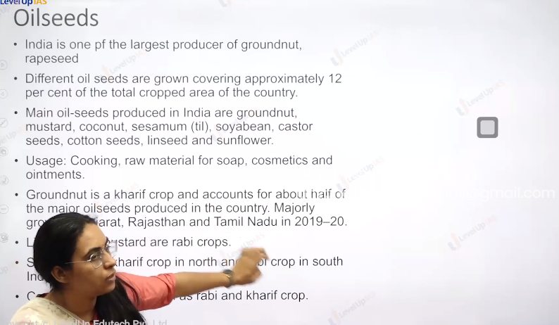

Oil seeds:

1. India one of largest producer of ground nut and rapeseed.
2. Oil seeds cover the 12% of total crop area.
3. Major oil seed produce are ground nut mustard, coconut, sesamum(til) , soyabean, castor seed, cotton seed linseed and sun flower.
4. Oil seeds are used in cooking and raw materials for many industries like soap, cosmetics ointment.
5. Ground nut accounts for half of major oil seed produce in the country.
6. Some oil seeds are kharif crop and others are rabi cope. Ex. Cotton Is kharif crop whereas linseed and mustard are grown as rabi crop.
7. Some of them are grown as kharif crop and rabi crop. Ex. Seasimum and caster seeds.

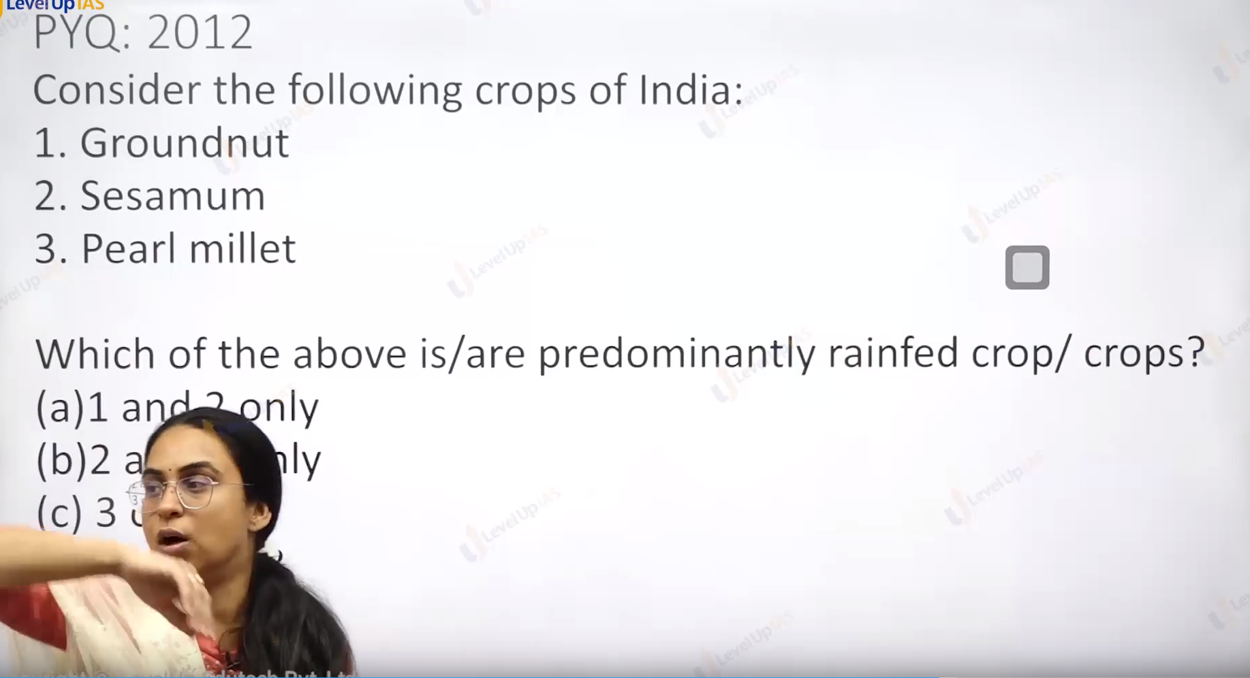

Ans: d all of above. Millet does not need more water.

Til no need to have separate irrigation.

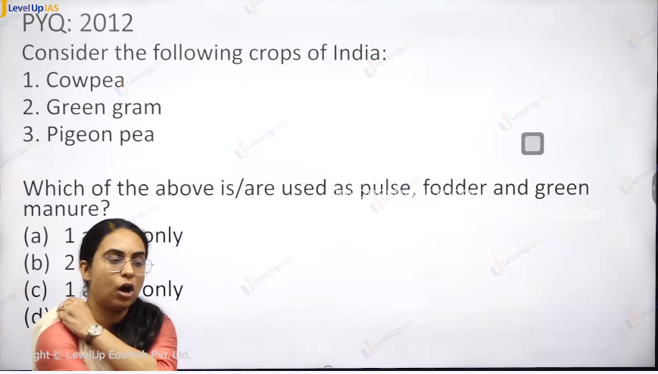

Ans s is all of the above.

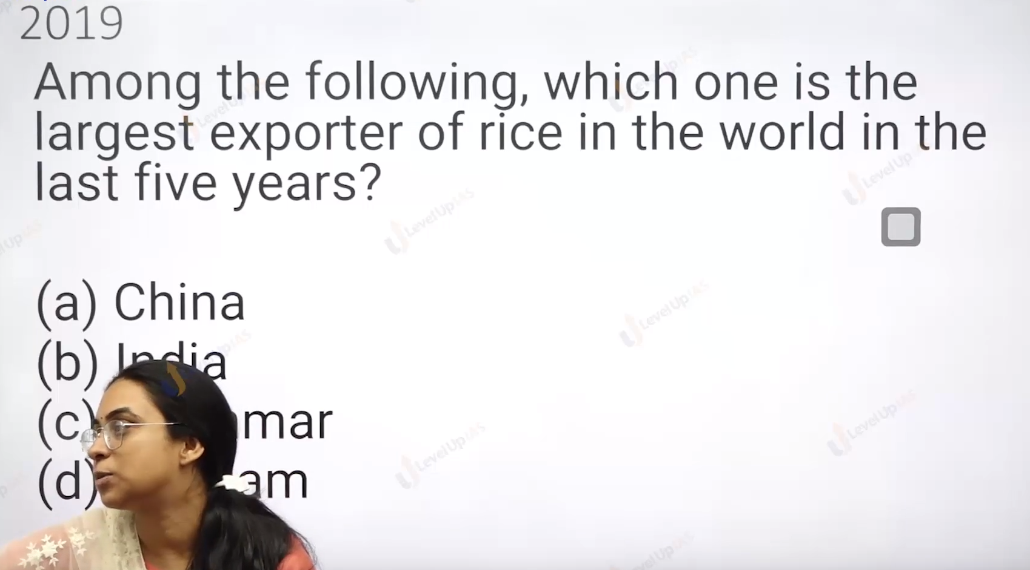

Ans is India.

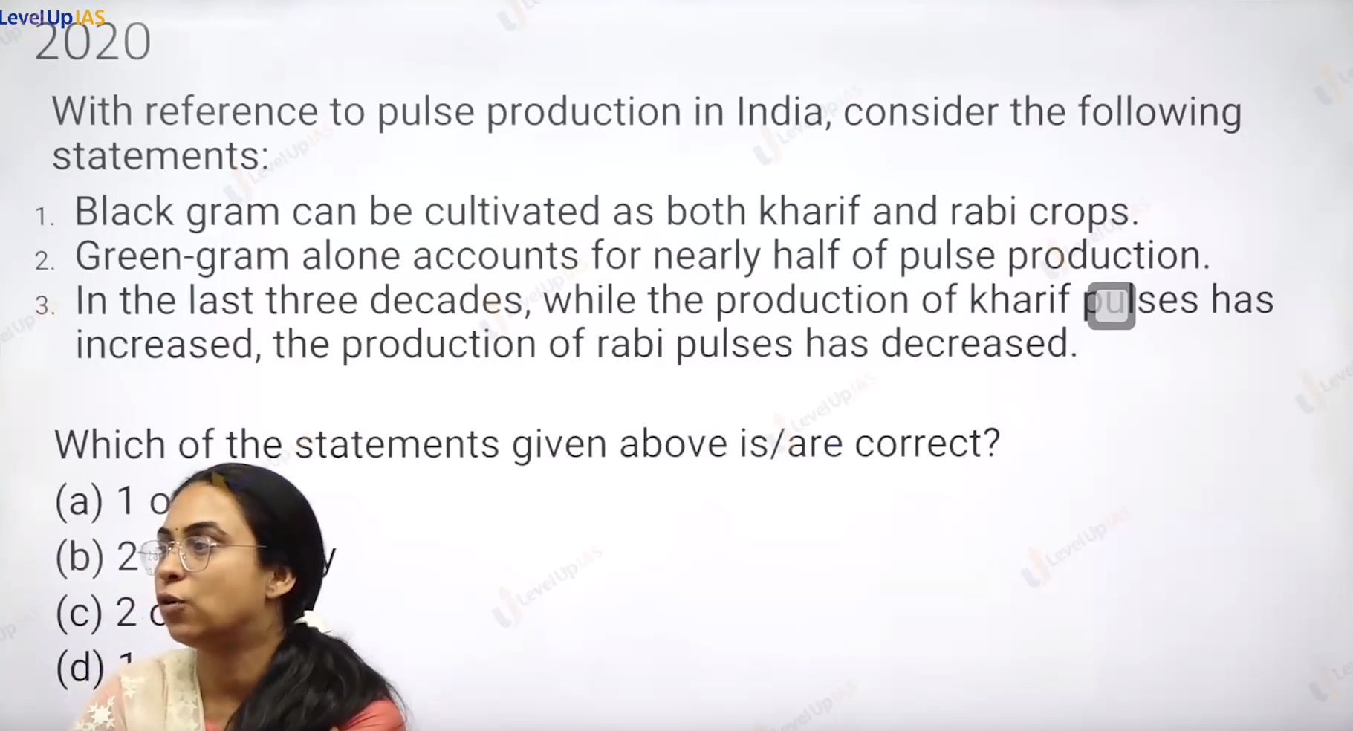

Ans:

1 only A.

